Incident Investigation Report
*Use this form to meet the compliance requirements of WAC 296-800-32025
(This form is an example, modify it as needed.)

Instructions: Incident investigators complete this form as soon as possible after an incident that results in serious injury or illness. (Optional: Use to investigate a minor injury or near miss that could have resulted in a serious injury or illness.)

This is an investigation report of a:  Close Call (“Near Miss”)  First Aid Only  Dr. Visit Only  Lost Time  Death | Did injured employee submit a Report of Injury, Illness, or Close Call?  Yes  No

Step 1: Injured employee (complete this part for each injured employee)
Name: | Sex: Male Female |  | Age:
Department: | Job title at time of incident:
Part of body affected: (shade all that apply)  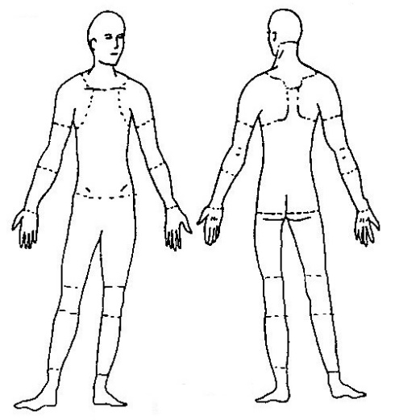 | Nature of injury: (most serious one)  Abrasion, scrapes  Amputation  Broken bone  Bruise  Burn (heat)  Burn (chemical)  Concussion (to the head)  Crushing injury  Cut, laceration, puncture  Eye injury  Hernia  Illness  Sprain, strain  Damage to a body system (e.g., nervous, respiratory, or circulatory systems):  Other:_______________ | This employee works:  Regular full time  Regular part time  Seasonal  Temporary
Years/months with
this employer:
Years/months doing
this job:

Step 2: Describe the incident
Incident Date: |  | Exact location of the incident: |  |  | Exact time:
What part of employee’s workday?
Entering or leaving work
Doing normal work activities
During meal period
During break
Working overtime
Other
Names of witnesses (if any):
Number of attachments: | Written witness statements: |  | Photographs: | Maps / drawings:
What personal protective equipment was being used (if any)?
Describe step by step the events that led up to the injury. Include names of any machines, parts, objects, tools, materials and other important details.

Description continued on attached sheets:

Step 3: Why did the incident happen?
Unsafe workplace conditions: (Check all that apply)  Inadequate guard  Unguarded hazard  Safety device is defective  Tool or equipment defective  Workstation layout is hazardous  Unsafe lighting  Unsafe ventilation  Lack of needed personal protective equipment  Lack of appropriate equipment / tools  Unsafe clothing  No training or insufficient training  Other: _____________________________ |  | Unsafe acts by people: (Check all that apply)  Operating without permission  Operating at unsafe speed  Servicing equipment that has power to it  Making a safety device inoperative  Using defective equipment  Using equipment in an unapproved way  Unsafe lifting by hand  Taking an unsafe position or posture  Distraction, teasing, horseplay  Failure to wear personal protective equipment  Failure to use the available equipment / tools  Other: _____________________________
Unsafe environment? (Check all that apply)  Light  Dark  Indoors  Outside  Uneven ground  Other: ____________________________ | Visibility (fog or shadows)  Windy  Wet  Heat  Cold weather or ice
Why did the unsafe conditions exist?
Why did the unsafe acts occur?
Is there a reward (such as “the job can be done more quickly”, or “the product is less likely to be damaged”) that may have encouraged the unsafe conditions or acts? Yes No
If yes, describe:
Were the unsafe acts or conditions reported prior to the incident? Yes No
Have there been similar incidents or near misses prior to the incident? Yes No

Step 4: How can future incidents be prevented?
What corrective action(s) do you suggest to prevent this incident/near miss from happening again?
Stop this activity Write a new policy/rule
Guard the hazard Enforce existing policy
Train the employee(s) Routinely inspect for the hazard
Train the supervisor(s) Personal Protective Equipment
Redesign task steps Other: ____________________
Redesign work station
What should be (or has been) done to carry out the suggestion(s) checked above?

Description continued on attached sheets:

Step 5: Who completed and reviewed this form? (Please Print)
Written by: | Title:
Department: | Date:
Names of investigation team members:
Manager review by: |  | Date:
Manager comments:
Safety Director review by: |  | Date:
Safety Director comments:

